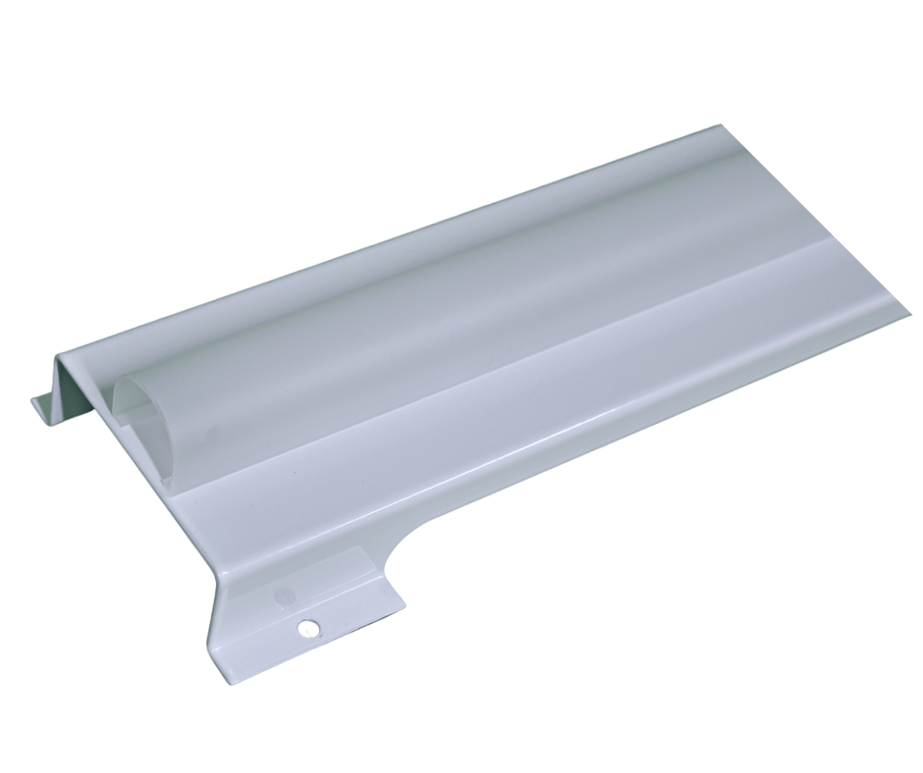

VULKAAN Retro-fit LED Gear Tray
PATENT PENDING

Product Description

The VULKAAN is an LED retrofit and universal gear tray that is designed to replace two fluorescent tubes in most watertight luminaires in a marine environment. It boasts a unique and rapid magnetic fixing system, which is tested and proven to withstand the full rigor of a marine environment, including the full range of vibrations that a ship experiences from the deck to the bow thruster room. The VULKAAN typically produces slightly more light than the existing fluorescent tubes but uses 75% less energy. It has a specialist diffuser with optics that are designed to project the light in a batwing spread whilst removing any glare. The steel frame performs as a heat sink for the LED whilst also giving it rigidity and structure to maximize life expectancy, holding the light output at an incredibly high level over its 8.5-year life at 24/7 use.

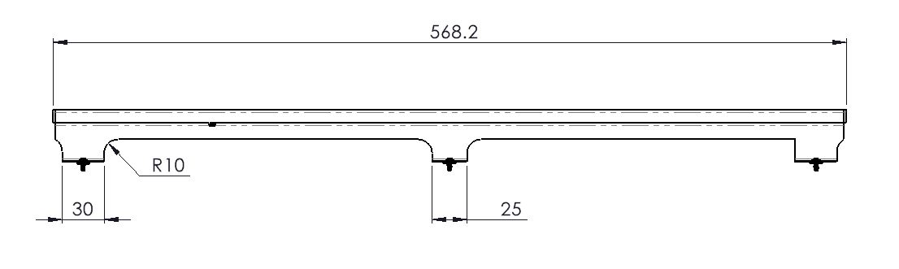

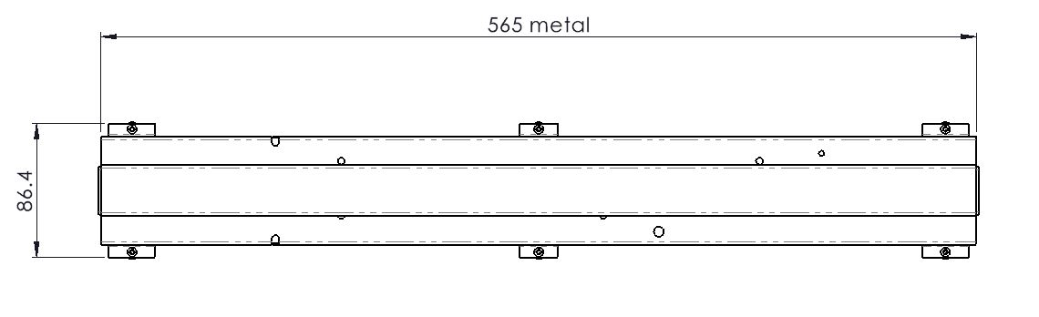

Designed and Manufactured in the United Kingdom

Specification
UK
VULKAAN | LED Retrofit Gear Tray
Wattage (WW) | 11W (11) | 22W (22)
Voltage/Hz | 220-240V, 50/60Hz
Lumens/W | 165lm/w
Light Colour (YY) | 3000K (WW), 4000K (40), 5000K (50), 6,500 (65)
CR Index | CRI 80+
Protection Class | Installed inside marine existing luminaire
Dimensions (mm) | 565 x 88 x 42 | 1175 x 88 x 42
Fixing/Mounting | Vibration resistant magnetic fixture
Construction/Finish | White powder coated steel
Life (hours) | 72000 (LED) 100000 (driver)
Operating Temperature | -20ᵒC - +65ᵒC
Warranty | 5 years
Product Code | TGTWWYY

